KpFun
App Revision April 2014

GPS
The GPS location needs to update frequently so if the user moves and the search refreshes there will be a new set of restaurants based on their location.

Address
On the Restaurant Detail page, Reward Page and Gift View, the address needs to be a clickable link that will open up on Google Map to give them directions to get there.

Restaurant Detail Page ActivityRestaurantDetails.java
The layout needs updated on this page. The changes are documented in the images below.

Please note, the reward field is new (on top of black gradient).

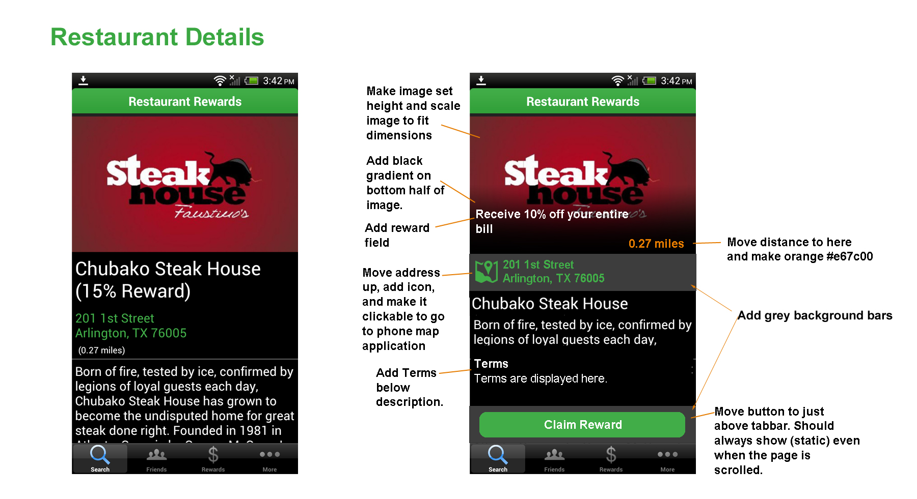

Ad View
When someone selects a row from the ActivityRestaurantSearch.java page there is a possibility it is an Ad and not a Restaurant. Currently it displays just like a restaurant would in ActivityRestaurantDetail.java We want this page to look a little different, you can use a new view or programmatically edit the Restaurant Details view. We want it to look like Ad View as shown in the image below. The field 'video' will have the youtube identifier. For example video=”aQDsfnFNIDU” goes to https://www.youtube.com/watch?v=aQDsfnFNIDU

It should display the youtube thumb and when clicked the video should play on the phone without leaving the app. The text that shows on the button at the bottom should be from returned the 'button' field, and it should direct people to the URL in the 'website' field.

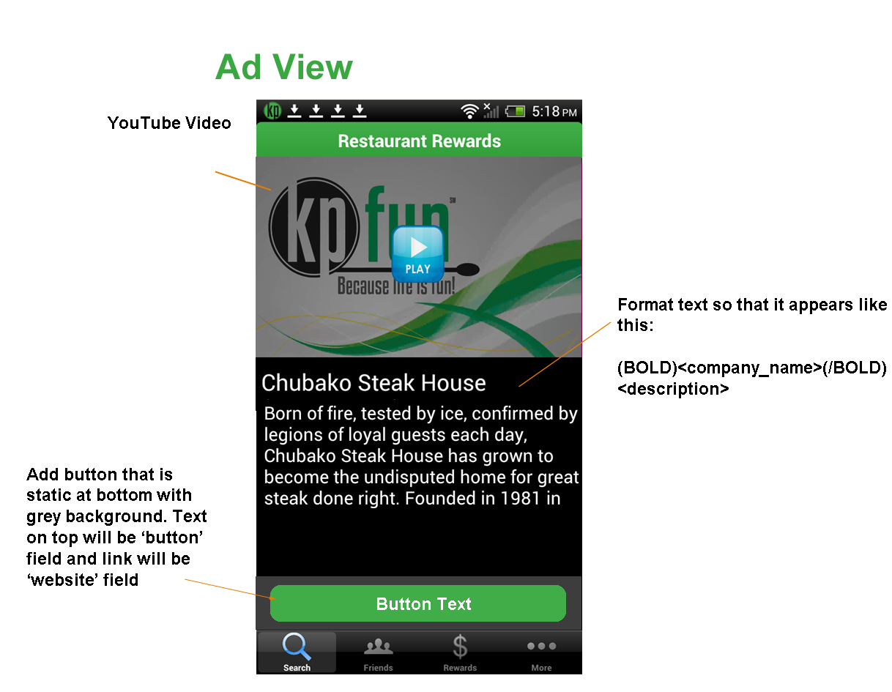

Reward Screen
The reward screen needs layout changes. They are documented below in the image. Please pay special attention to how the information is reformatted. The < > brackets denote the field name that is returned from the api call.

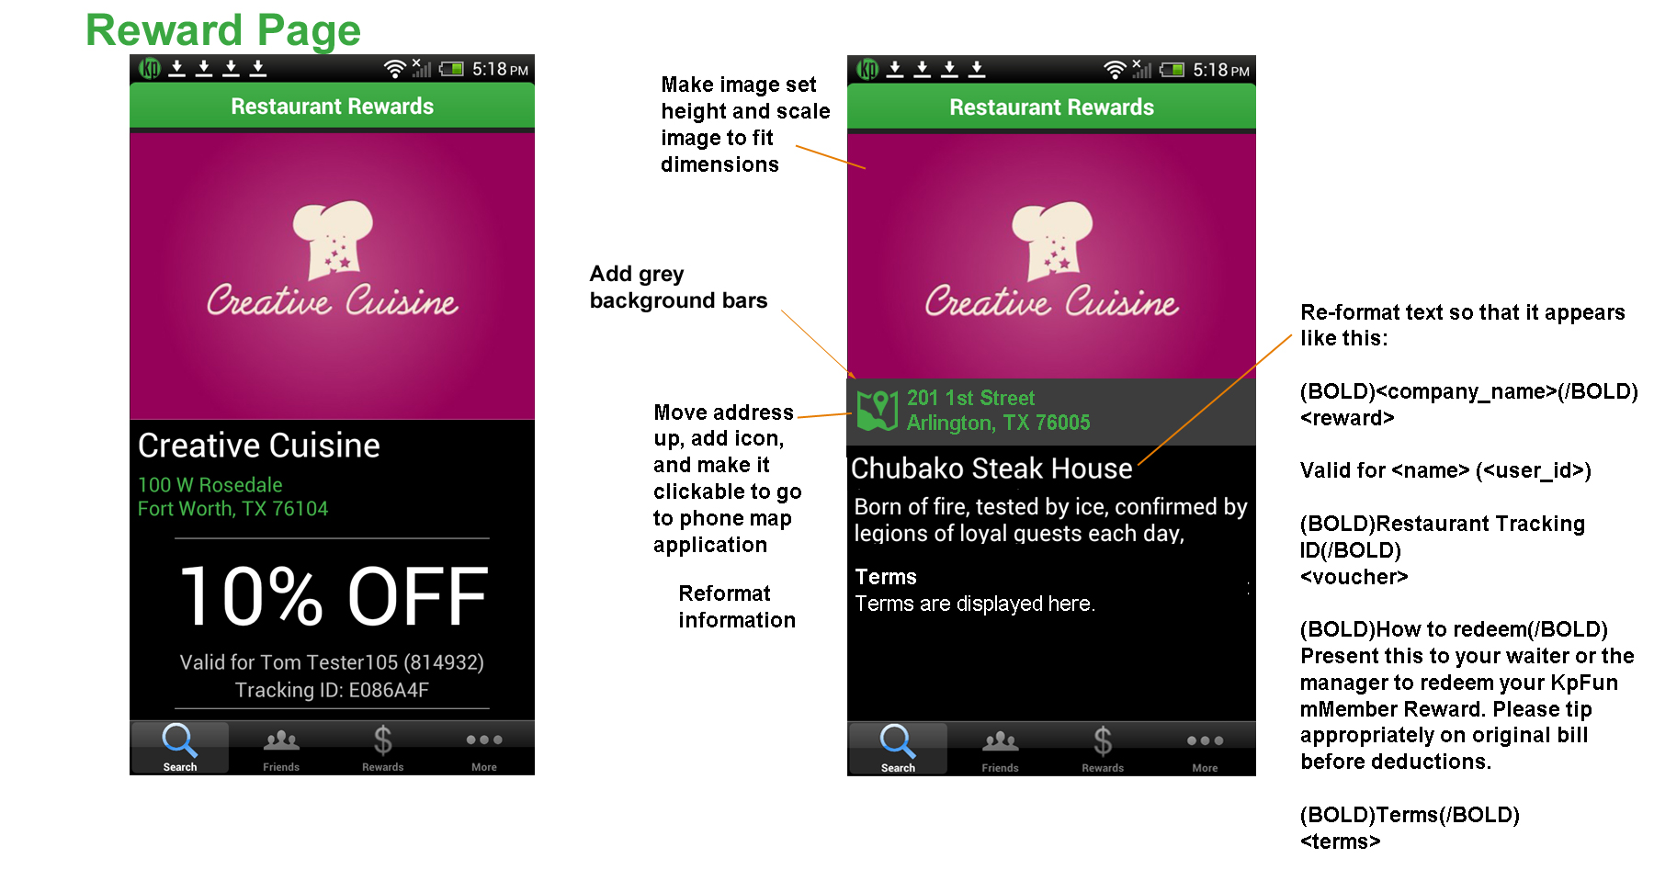

Share Gift
This page has some layout changes, much like the previous pages. The changes are shown below. Please note the text on the button needs to be changed as well.

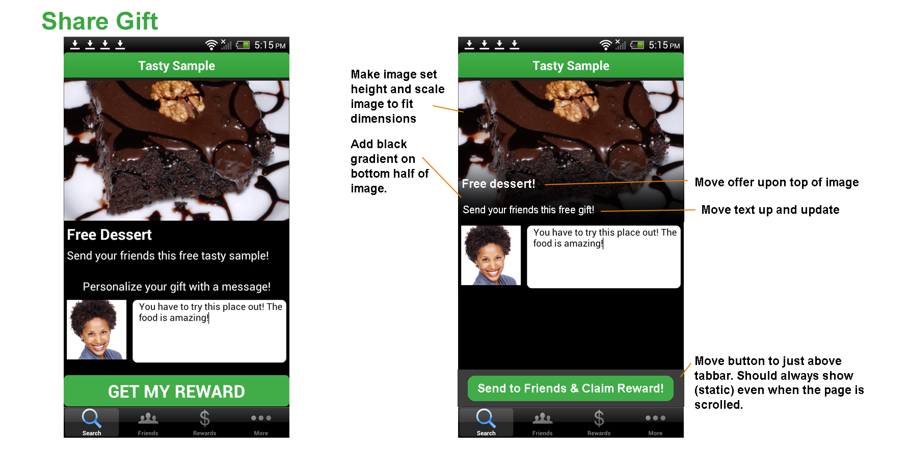

Reward Page
The layout on the Reward Page needs updated much like the previous pages. Please pay special attention to the format of the text.

